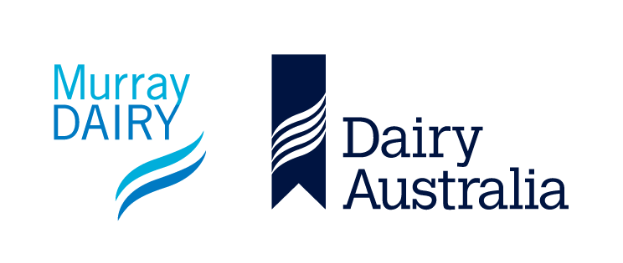

Board members

Murray Dairy is recruiting for three Directors (one Farmer Director and two Specialist Skills Directors) to formally commence in October 2024. Current farmer Director Hamish Crawford and Specialist Skills Director (Industry) Phil Candy, have both completed one three-year term and as in accordance with the Murray Dairy constitution are eligible to apply for a second three-year term. They have both renominated for their positions. The third position is available due to Specialist Skills Director (Finance) choosing not to reapply.

Murray Dairy is a Company Limited by Guarantee representing dairy farmers throughout the Murray Dairy region of Northern Victoria and Southern New South Wales. It is responsible for coordinating and investing in a comprehensive research, development and extension portfolio across the Murray Dairy region.

The Murray Dairy Board is eager to recruit applicants who can demonstrate knowledge of, or experience in, one or more of the following fields:

- Business management – finance and/or accounting
- Strategy, risk management, legal matters and project management
- Stakeholder engagement and relationships – government, industry and industry partners
- Leadership inclusive of culture and organisational values and behaviours
- Dairy farming experience
- Dairy industry structures and associated organisations
- Supply chain – food processing, marketing and promotion, trade
- Research, development, education and extension
- Productivity – farm business management and risk mitigation, farm systems, feedbase, animal nutrition and animal performance
- Sustainability – water, climate, emissions, soils and/or carbon
- People – attraction, retention and development
- HR – compliance, WH&S

An independent selection committee has been tasked with overseeing the recruitment process and to help identify suitable applicants for the three available positions.

Murray Dairy recognises the benefits of having a diverse Board and encourages a diversity of applications for the advertised positions.

Candidates interested in applying for the advertised positions need to download and fill out the Expression of Interest form and email it to admin@murraydairy.com.au by 5:00pm Friday 12 July 2024.

For more information, please refer to the position description and selection criteria or contact the Murray Dairy Office at admin@murraydairy.com.au

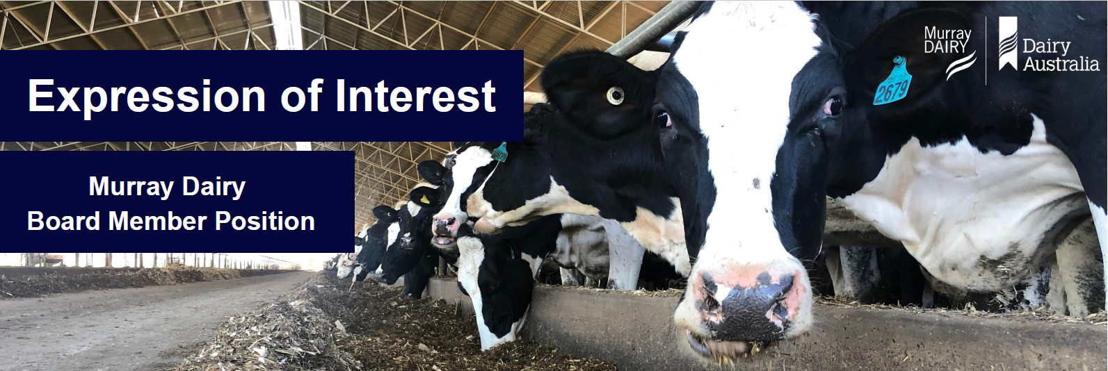

To be considered for this board position, applicants must complete and provide the following:
- Expression of Interest form, including addressing the knowledge, experience and skills criteria
- Provide a CV
- Covering letter

Application to be signed and email to – admin@murraydairy.com.au by 5pm Thursday 4 July 2024

Name
Title | Full name
Preferred Address for Correspondence
Address | Suburb/City | Postcode
Contact Numbers
Business Hours | After Hours | Other
Academic Qualifications – including Qualifications, Institution & Year Graded
Current Occupation and Employer – including Title, Employer & Period of Employment
in areas required by Murray Dairy
(Please describe

your qualifications and/or experience in the following fields)

Knowledge, Experience & Skills in areas required by Murray Dairy
(Please describe your qualifications and/or experience in the following fields)
- Business management – finance and/or accounting

- Stakeholder engagement and relationships – government, industry and industry partners

- Leadership inclusive of culture and organisational values and behaviours

- Dairy farming experience

- Dairy industry structures and associated organisations

- Supply chain – food processing, marketing and promotion, trade

- Research, development, education and extension

- Productivity – farm business management and risk mitigation, farm systems, feedbase, animal nutrition and animal performance

- Sustainability – water, climate, emissions, soils and/or carbon

- People – attraction, retention and development

- Strategy, risk management, legal matters and project management

- HR – compliance, WH&S

Personal Attributes
Relevant Committee and Board Experience
Application to be signed and email to
admin@murraydairy.com.au by 5pm Thursday 4 July 2024

Print Name:

Signature: Date:

