Australian Dairy Carbon Calculator

Manual

Version 5

Section 6 only - DFMP benchmarking

November 2022

## Acknowledgements

Dairy Australia and the Tasmanian Institute of Agriculture (TIA) would like to acknowledge and give thanks to Meat & Livestock Australia and Integrity Ag & Environment for the use of background text (e.g. information on GHG emissions, emission sources etc) from their carbon accounting technical manual for the Sheep Beef Greenhouse gas Accounting Framework (SB-GAF) calculator.

We would also like to thank Agriculture Victoria for allowing the reproduction of Figure 1 (adapted with updated GWPs for this manual).

The original Australian Dairy Carbon Calculator (ADCC), previously known as the Dairy Greenhouse gas Abatement Strategies (DGAS) calculator, was developed in the late 2000’s with funding from Dairy Australia and the Australian Government Department of Agriculture, Fisheries and Forestry.

Over time, the calculator has been maintained and upgraded within projects funded by the Australian Federal Government Department of Agriculture, Fisheries and Forestry, Dairy Australia, Meat & Livestock Australia, and Australian Wool Innovation. Version 5 of ADCC was funded by Dairy Australia. We acknowledge funding from all above-mentioned agencies to allow the development and upgrading of the calculator as required to meet the most current guidelines.

Many thanks to the Agriculture Victoria team for providing access to the Dairy Farm Monitor Project and Queensland Dairy Accounting Scheme datasets. This allowed us to review 1,775 dairy farm datasets to benchmark GHG emissions.

Lastly, a huge thank you to everyone who took the time to review this manual.

Citation:

KM Christie and Dairy Australia (2022) Australian Dairy Carbon Calculator (ADCC).

(Tasmanian Institute of Agriculture: Launceston, Tasmania; Dairy Australia: Melbourne, Victoria).

This publication is published by Dairy Australia Limited ABN 60 105 227 987. Dairy Australia and TIA, along with Meat & Livestock Australia and Integrity Ag & Environment, have endeavoured to ensure that all information in this publication is correct. However, we make no warranty with regard to the accuracy of the information and will not be liable if the information is inaccurate, incomplete, or out of date. The contents should not be used as a substitute for seeking independent professional advice. You should make your own enquiries before making decisions concerning your interests. Reproduction in whole or in part of this publication is prohibited without prior written consent of Dairy Australia.

Table of Contents

Acknowledgements 2

1. Australian Dairy Carbon Calculator Manual 4

2. Glossary and commonly used acronyms 5

6. Benchmarking of DairyBase results 10

8. Resources 19

9. References 21

10. Appendices 24

# Australian Dairy Carbon Calculator Manual

The Australian Dairy Carbon Calculator manual contains four theme areas:

* Carbon accounting (sections 1-4),
* Australian Dairy Carbon Calculator (section 5),
* Benchmarking of Dairy Farm Monitor Project data (section 6), and
* GHG adaptation options explored in the Carbon Offset Scenario Tool (section 7)

This version of the manual only contains the Benchmarking of Dairy Farm Monitor Project data (section 6) along with the Glossary and commonly used acronyms (section 2), full listing of resources and appropriate appendices (sections 8 and 10). If you wish to access all or some of the other sections of the ADCC manual, you can find these on the Dairy Australia website. Note the Table and Figure numbers in this section match those of the full manual; they have not recommenced as Table or Figure 1.

# Glossary and commonly used acronyms

|  |  |
| --- | --- |
|  |  |
| 3-NOP | 3-nitrooxypropanol trading as Bovaer® |
| Abatement | Strategy to reduce net GHG emissions |
| ADCC | Australian Dairy Carbon Calculator |
| Allocation | Dairy farms produce milk and meat. ADCC allocates net GHG emissions, based on an energy allocation method, to milk and meat |
| Anthropogenic | GHG emissions caused or influenced by people, either directly or indirectly |
| AR4 | IPCC Fourth Assessment Report |
| AR5 | IPCC Fifth Assessment Report |
| Benchmarking | Comparing the performance of the enterprise against the rest of the industry |
| Carbon accounting | The process used to qualify greenhouse gas (GHG) emissions of an enterprise |
| Carbon flux | The change in carbon stocks stored in sinks over a duration, usually a yearly basis |
| Carbon footprint | Quantification of the GHG emissions emitted directly or indirectly by an individual, company, or product |
| Carbon negative/carbon positive | Condition in which net carbon dioxide equivalent emissions are negative and positive, respectively. However, these terms can be ambiguous and are sometimes used inconsistently. Therefore, the dairy industry is moving away from the use of these terms and referring to a farm as remaining either an emitter of emissions (i.e. has not attained carbon neutrality/net zero), as net zero (all emissions offset by carbon sequestration), or a beyond net zero (sequestering more carbon than emitting) |
| Carbon neutrality | Net-zero GHG emissions |
| Carbon sequestration | The process whereby carbon dioxide is removed from the atmosphere and stored in carbon sinks such as soils and vegetation |
| Carbon sink | A reservoir that absorbs carbon dioxide from the atmosphere. Natural carbon sinks include plants, soils, and oceans |
| Carbon stocks | Carbon stocks refers to the quantity of carbon that has been sequestered from the atmosphere and is stored in a carbon sink |
| CFI | Carbon Farming Initiative; the original Federal government voluntary carbon credit scheme, later replaced with the ERF and subsequently the CSF |
| CH4 | Methane |
| CO2 | Carbon dioxide |
| CO2e | Carbon dioxide equivalents (CO2e) are a unit used to compare emissions from different GHGs based on their global warming potential (GWP) over a specific timeframe, typically 100 years (GWP100) |
| COST | Carbon Offset Scenario Tool, a series of mitigation options embedded within ADCC |
| CP | Crude protein |
| CSF | Climate Solutions Fund; the Australian Government’s most recent voluntary carbon credit scheme, formerly known as the CFI and subsequently the ERF |
| DFMP | Dairy Farm Monitor Project |
| DGAS | Dairy Greenhouse gas Abatement Strategies calculator, the original name for ADCC |
| Direct N2O | Nitrous oxide lost to the environment from deposition of urine, dung, effluent, and nitrogen-based fertilisers (see indirect N2O) |
| DM | Weight of feed after all moisture is removed |
| DMD | Dry matter digestibility |
| DMI | Dry matter intake is the amount of moisture-free feed an animal consumes, usually referred to on a daily basis |
| EF | Emission factor |
| Emissions intensity | Emissions intensity (EI) is a metric based on the net GHG emissions relative to the output (e.g. kg of fat and protein corrected milk or kg liveweight). EIs allow for comparison and benchmarking between farms of different sizes and production levels |
| Energy allocation | ADCC allocated GHG emissions based on the total energy attributed to milk production versus meat production |
| Enteric methane | Enteric methane is produced through enteric fermentation when plant material is broken down in the rumen and is a by-product of this digestive process. Methane is released primarily through belching and exhalation |
| ERF | Emissions Reduction Fund is the Australian Government’s second voluntary carbon credit scheme, formerly known as the CFI and then later replaced with the CSF |
| FPCM | Fat and protein-corrected milk is a kg of milk standardised to 4.0% fat and 3.3% protein to allow comparison of milk with varying fat and protein percentages |
| GHGs | Greenhouse gases are gases that absorb and emit radiant energy. The main GHGs associated with agriculture are carbon dioxide (CO2), methane (CH4), and nitrous oxide (N2O) |
| Global temperature potential | Global Temperature Potential (GTP) is an alternative to GWP100 to report the warming potential of methane, based on the change in global mean surface temperature, usually on a yearly time-step |
| Global warming potential | Global warming potential (GWP) is a measure of cumulative radiative forcing, which aims to quantify the long-term contribution of a GHG to global warming. Each GHG has a specific GWP value, and this is relative to a specific timeframe |
| GWP100 | Global warming potential based on a 100-year time horizon |
| IPCC | Intergovernmental Panel on Climate Change, established in 1988 to provide scientific information on anthropogenic climate change, including the impacts, risks, and possible response options |
| Indirect N2O | A proportion of the nitrogen applied to soils via animal urine, dung, and effluent, or as nitrogen-based fertilisers, can be lost to the environment as volatilised ammonia or leaching/runoff nitrate. Over time, this nitrogen is redeposited onto soils in rainfall (volatilised N) or deposited into water courses (leached/runoff N). A proportion of this redeposited nitrogen will be transformed into nitrous oxide through the processes of nitrification and denitrification |
| K | Potassium |
| LW | Liveweight of an animal, usually reported as kgs |
| LWG | Liveweight gain of an animal, usually reported as kg/day |
| Manure | Manure is used in this manual when referring to the sum of urine and dung. At times, waste is also used as an alternative term for manure. Unless stipulated, manure refers to the sum of urine and dung deposition |
| Manure management system | Manure management system (MMS) refers to the method of handling animal manure. MMSs for dairy include directly voided onto pastures during grazing, pond/lagoons, sump/dispersal, drains to paddock daily, and solid storage |
| Methane conversion factor | Methane conversion factor (MCF) defines the proportion of methane-producing potential of each manure management system. Pond/lagoons have a higher MCF than other storage systems |
| Methane | Methane (CH4) is a GHG that is 28 times more potent than carbon dioxide over a 100-year timeframe, based on the IPCC AR5 report. Methane is released to the environment via the digestion process (enteric CH4) and with manure management (waste CH4) |
| N | Nitrogen |
| Net emissions | Total GHG emissions minus carbon sequestered in carbon sinks (trees and/or soils) |
| NGGI | The National GHG Inventory accounts for, and estimates, Australia’s GHG emissions and sinks |
| NGER | National Greenhouse and Energy Reporting |
| NH4 | Ammonium |
| Nitrous oxide | Nitrous oxide (N2O) is a GHG that is 265 times more potent than carbon dioxide, based on the IPCC AR5 report. N2O is released to the environment when micro-organisms in the soil act on the nitrogen applied to the soil, whether that N is deposited via animal urine, dung, effluent or nitrogen-based fertilisers |
| N2O | Nitrous oxide |
| NO3 | Nitrate |
| P | Phosphorus |
| Pre-farm embedded emissions | GHG emissions associated with the production/manufacturing of key farm inputs such as grain, fodder, and fertiliser. In ADCC, pre-farm embedded emissions do not include the emissions associated with the transportation of these inputs from the point of production to the farm gate, due to the difficulty in establishing distances travelled for grain, fodder, and/or fertilisers |
| S | Sulphur |
| SAR | IPCC Second Assessment Report |
| Scope | Standard practice is to report GHG emissions using different classifications depending on where they arise from, and how they relate to the business. These are termed emission ‘scopes’ |
| Scope 1 emissions | Direct GHG emissions from sources that are owned or controlled by the business. For dairy farms, this refers to emissions from on-farm methane and nitrous oxide, along with carbon dioxide emissions from the consumption of fuel |
| Scope 2 emissions | GHG emissions from the generation of purchased electricity consumed by the business |
| Scope 3 emissions | GHG emissions that are a consequence of the activities of the business, but that occur from sources not owned or controlled by the business. For dairy farms, these are GHG emissions from the production of key farm inputs (i.e. pre-farm embedded emissions), extraction/refinement of fuel, and indirect loss of electricity through transmission and distribution in the grid |
| Waste | Waste is used in this manual when referring to the sum of urine and dung. At times, manure is used as an alternative term for waste. Unless stipulated, waste means the sum of urine and dung deposition |

# Benchmarking of DairyBase results

Benchmarking your farm data can be a good way of reviewing how your farm’s GHG emissions are tracking. This could be comparing results for your own farm over several years, or between your farm and others in your region. This section of the manual contains a range of analyses of the GHG emissions estimates from within Dairy Australia’s DairyBase program (<https://www.dairyaustralia.com.au/farm-business/dairybase>). These are datasets from the Dairy Farm Monitor Project (DFPM) for the years 2006/07 to 2020/21 inclusive. While DairyBase contains over 3,000 DFMP datasets, this review was restricted to the 1,775 datasets which contained a complete list of realistic input data. For example, datasets with missing electricity and/or diesel consumption data were excluded from the analysis (e.g. some of the earlier years for Tasmania). Likewise, datasets with N fertiliser inputs which appeared to be total tonnes, as opposed to kg N/ha, were also excluded. With the upgrade of DairyBase with new estimates for carbon stored in tree vegetation, the legacy data in DairyBase data did not include the age of tree plantings as well as a simplification of the tree species present on farm (see *Step Eight* in section 5.3). Therefore, estimating carbon sequestration in trees for these 1,775 datasets was impossible. Hence, all results presented in this section 5.8 do not contain any potential reduction in net GHG emissions with sequestering carbon in tree plantings.

Figure 24 illustrates the number datasets for each region/state that met the criteria of suitability as mentioned above. The DFMP commenced in the 2006/07 financial year in the three dairying regions of Victoria. New South Wales and South Australia commenced in 2012/13 (although there was a single dataset for Nth NSW for 2011/12 included), with Tasmania and Western Australia one year later in 2013/14. As shown in Figure 24, there was a rapid decline in the number of datasets in 2016/17, due to ~ 80 datasets missing electricity and fuel consumption data, thus failing to meet the criteria for this review.

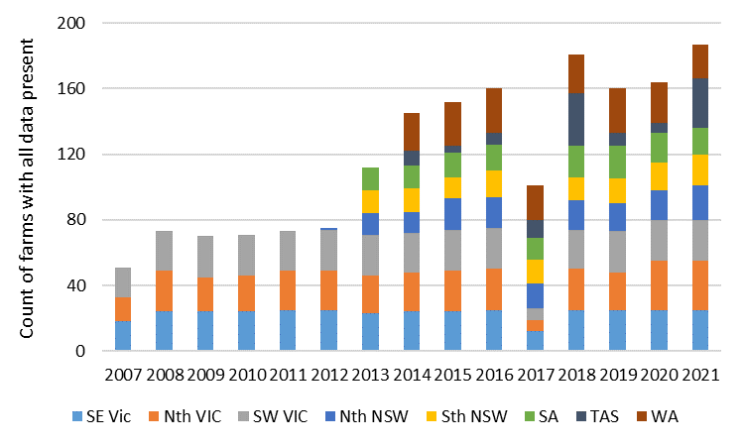

**Figure 24.** Number of Dairy Farm Monitor Project datasets for each year from each dairy region where all the data was included in DairyBase. Note the year reflects the second half of the financial year, so 2007 reflects 2006/07. No QLD data was assessed due to missing electricity and diesel consumption data.

Total farm milk production was assessed against net farm GHG emissions attributed to milk production (i.e. removal of GHG emissions attributed to meat production deducted from net farm GHG emissions), using a linear regression analysis (y=Bx+a). The slope of the regression (B value in the regression equation) was 0.92, with a residual ‘a’ value of 13 (Figure 25). The co-efficient of determination (R2; where an R2 of 1 indicates the regression prediction perfectly fits the data) was 0.97, thus indicating that this regression equation is an excellent predictor of net GHG emissions from milk production (Figure 25). Therefore, we can have high confidence that if a farm’s milk production was 5,000 t FPCM/annum, their approx. GHG emissions could be estimated as 5,000 x 0.92 + 13 = 4,613 t CO2e/annum.

However, the orange dot farm datasets in Figure 25 represent datasets where the standard residual is > 2, indicating the difference between their estimated GHG emissions, based on DairyBase, and that predicted, as derived by the regression equation, was more than 2 standard deviations away from the mean. Orange dots that sit above the blue regressions line indicate their GHG emissions estimated in DairyBase is greater than predicted from annual milk production. This could potentially indication inefficiencies on farm (i.e. lower conversion of N fertiliser into grass and then milk). Alternatively, less meat was sold than expected, resulting in DairyBase attributing a greater proportion of GHG emissions to milk production. Conversely, orange dots below the regression line indicate their GHG emission estimate in DairyBase was lower than predicted based on milk production. This could be a result of increased efficiency on farm and/or producing more meat than expected, thus DairyBase directed more GHG emissions towards meat production (Figure 25).

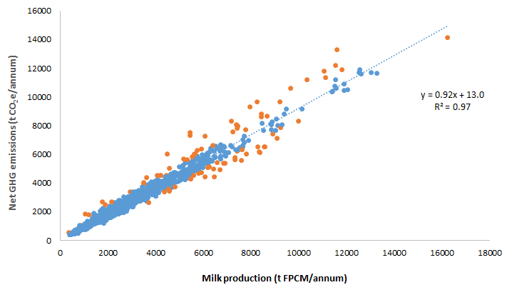

**Figure 25.** Linear regression relationship between milk production (t FPCM/annum) and net GHG emissions (t CO2e/annum). The orange dots indicate farm datasets with a standard residual > 2, indicative of outlier results relative to the linear regression relationship.

The EI of milk production, prior to taking an allocation of meat production into consideration, is presented in Table 1. The overall mean for Australia, across the 13 years of data, was 1.07 kg CO2e/kg FPCM. This is a 4.5% increase in results based on the previous NGGI methodology, at 1.03 kg CO2e/kg FPCM. The main reason for the increase was most likely due to an increase in GWP of CH4 (see sections 5.5 and 5.6 for explanations of the changes that have occurred since the update of the calculator with the newest NGGI methodology).

**Table 1.** Mean regional and national emissions intensity (kg CO2e/kg FPCM) when allocating all GHG emissions to milk production. Old NGGI refers to the 2017 methodology results. FY 2007 reflects the 2006-07 financial year.

|  |  |  |  |  |  |  |  |  |  |  |  |
| --- | --- | --- | --- | --- | --- | --- | --- | --- | --- | --- | --- |
| **Year** | **SE Vic** | **Nth Vic** | **SW VIC** | **Nth**  **NSW** | **Sth NSW** | **SA** | **TAS** | **WA** | **Aus wide** | **No. farms** | **Old**  **NGGI** |
| FY 2007 | 1.16 | 1.18 | 1.04 |  |  |  |  |  | 1.12 | 51 | 1.09 |
| FY 2008 | 1.11 | 1.04 | 1.10 |  |  |  |  |  | 1.08 | 73 | 1.04 |
| FY 2009 | 1.06 | 1.02 | 1.04 |  |  |  |  |  | 1.04 | 70 | 1.00 |
| FY 2010 | 1.09 | 1.05 | 1.03 |  |  |  |  |  | 1.06 | 71 | 1.02 |
| FY 2011 | 1.03 | 1.02 | 1.07 |  |  |  |  |  | 1.04 | 73 | 1.00 |
| FY 2012 | 1.03 | 1.02 | 1.06 | 1.15 |  |  |  |  | 1.04 | 75 | 1.01 |
| FY 2013 | 1.10 | 1.02 | 1.06 | 1.20 | 1.08 | 1.01 |  |  | 1.07 | 112 | 1.03 |
| FY 2014 | 1.08 | 1.01 | 1.09 | 1.24 | 1.07 | 1.09 | 1.08 | 1.11 | 1.09 | 145 | 1.05 |
| FY 2015 | 1.05 | 1.01 | 1.06 | 1.23 | 1.04 | 0.99 | 1.19 | 1.09 | 1.07 | 152 | 1.03 |
| FY 2016 | 1.08 | 1.02 | 1.04 | 1.20 | 1.05 | 1.00 | 1.00 | 1.07 | 1.06 | 160 | 1.03 |
| FY 2017 | 1.09 | 1.06 | 1.07 | 1.17 | 1.10 | 0.99 | 1.02 | 1.02 | 1.07 | 101 | 1.01 |
| FY 2018 | 1.08 | 1.02 | 1.11 | 1.23 | 1.10 | 1.00 | 1.02 | 1.15 | 1.08 | 181 | 1.01 |
| FY 2019 | 1.11 | 1.04 | 1.15 | 1.25 | 1.12 | 1.01 | 0.98 | 1.14 | 1.11 | 160 | 1.05 |
| FY 2020 | 1.06 | 0.99 | 1.09 | 1.22 | 1.10 | 1.01 | 0.99 | 1.15 | 1.08 | 164 | 1.02 |
| FY 2021 | 1.04 | 0.99 | 1.05 | 1.20 | 1.07 | 0.96 | 0.99 | 1.17 | 1.05 | 187 | 1.00 |
| Average | 1.08 | 1.03 | 1.07 | 1.21 | 1.08 | 1.01 | 1.02 | 1.11 | 1.07 | 1,775 | 1.03 |
| No. farms | 348 | 343 | 346 | 154 | 137 | 145 | 107 | 195 | 1,775 |  | 1,149 |

However, as documented previously in this manual, meat production has become an increasing component of farm exports. ADCC and DairyBase allocate a proportion of GHG emissions to meat production. The legacy data within DairyBase estimated the likely number of calves born each year, assumed to be a 50:50 split between heifer and bull calves. The number of Heifers < 1 yr age was subtracted from total number of heifer calves born, with these ‘non-replacement’ heifer calves sold soon after birth. Similarly, all bull calves were assumed to be sold soon after birth, unless there were stock numbers included in the Other Livestock class. For example, if a farm had 400 cows milking, it was assumed there would also be 400 calves. If there were 100 Heifers < 1 yr age, and 100 Other Livestock, ADCC assumed that the balance 200 calves were sold soon after birth. The meat EI represents all meat sold off farm from culled cows, surplus calves, fattened livestock, and any additional Rising 1 year old replacement heifers not required to match the Rising 2 yr old replacement numbers. For example, if a farm had 120 Rising 1 year olds, and 110 Rising 2 years olds, 10 of the Rising 1 year olds were assumed to have been sold post-weaning at 150-200 kg liveweight.

After considering an allocation of net GHG emissions to meat production, the national EI of milk production reduced from 1.07 to 0.93 kg CO2e/kg FPCM (Table 2). Unlike the results in Table 1, there is no comparative Old NGGI methodology milk EI comparison as this analysis could not be retrospectively completed. There were minimal differences in meat EI across regions and years. However, the pattern generally trended the same way as milk EI. For example, Nth NSW had the highest milk and meat EIs. Most of the datasets had a milk EI of between 0.85 and 1.04 kg CO2e/kg FPCM (Figure 26), while most meat EIs varied between 3.9 and 4.8 kg CO2e/kg liveweight (Figure 27).

**Table 2.** Mean regional and national milk emissions intensity (kg CO2e/kg FPCM), and meat emissions intensity (kg CO2e/kg liveweight), when allocating a proportion of GHG emissions to meat production. FY 2007 reflects the 2006-07 financial year.

|  |  |  |  |  |  |  |  |  |  |  |
| --- | --- | --- | --- | --- | --- | --- | --- | --- | --- | --- |
| **Year** | **SE Vic** | **Nth Vic** | **SW VIC** | **Nth**  **NSW** | **Sth NSW** | **SA** | **TAS** | **WA** | **Aus wide** | **Meat EI** |
| FY 2007 | 1.00 | 1.02 | 0.92 |  |  |  |  |  | 0.98 | 4.7 |
| FY 2008 | 0.96 | 0.91 | 0.97 |  |  |  |  |  | 0.95 | 4.5 |
| FY 2009 | 0.93 | 0.91 | 0.92 |  |  |  |  |  | 0.92 | 4.4 |
| FY 2010 | 0.96 | 0.93 | 0.91 |  |  |  |  |  | 0.93 | 4.4 |
| FY 2011 | 0.91 | 0.90 | 0.94 |  |  |  |  |  | 0.91 | 4.4 |
| FY 2012 | 0.91 | 0.90 | 0.93 | 1.04 |  |  |  |  | 0.92 | 4.4 |
| FY 2013 | 0.97 | 0.90 | 0.93 | 1.05 | 0.93 | 0.89 |  |  | 0.94 | 4.4 |
| FY 2014 | 0.94 | 0.89 | 0.95 | 1.07 | 0.94 | 0.94 | 0.91 | 0.95 | 0.95 | 4.4 |
| FY 2015 | 0.93 | 0.89 | 0.93 | 1.05 | 0.91 | 0.87 | 1.02 | 0.95 | 0.94 | 4.4 |
| FY 2016 | 0.95 | 0.90 | 0.93 | 1.04 | 0.91 | 0.88 | 0.87 | 0.92 | 0.93 | 4.3 |
| FY 2017 | 0.94 | 0.92 | 0.93 | 1.02 | 0.94 | 0.87 | 0.89 | 0.89 | 0.93 | 4.3 |
| FY 2018 | 0.94 | 0.90 | 0.97 | 1.06 | 0.95 | 0.88 | 0.88 | 0.94 | 0.93 | 4.4 |
| FY 2019 | 0.96 | 0.91 | 0.99 | 1.06 | 0.98 | 0.88 | 0.84 | 0.92 | 0.95 | 4.4 |
| FY 2020 | 0.93 | 0.88 | 0.95 | 1.04 | 0.96 | 0.89 | 0.85 | 0.94 | 0.93 | 4.3 |
| FY 2021 | 0.91 | 0.88 | 0.92 | 1.01 | 0.93 | 0.85 | 0.85 | 0.91 | 0.91 | 4.2 |
| Average | 0.94 | 0.90 | 0.94 | 1.04 | 0.94 | 0.88 | 0.87 | 0.93 | 0.93 | 4.4 |

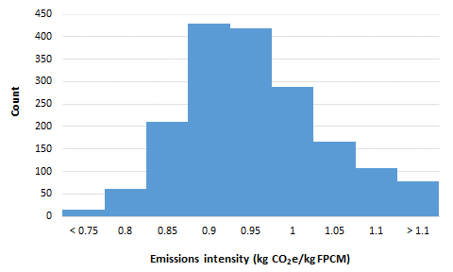

**Figure 26.** Frequency of emissions intensity of milk production across the 1,775 datasets once a proportion of GHG is allocated to meat production. EIs broken down into 0.05 kg CO2e/kg FPCM increments where the number listed for each column is the upper limit such that 0.8 reflects the number of datasets with an EI between 0.75 and 0.80 kg CO2e/kg FPCM.

**Figure 27.** Frequency of emissions intensity of meat production (kg CO2e/kg liveweight sold) across the 1,775 datasets. EIs broken down into 0.3 kg CO2e/kg liveweight increments where the number listed for each column is the upper limit such that 3.90 reflects the number of datasets with an EI between 3.6 and 3.9 kg CO2e/kg liveweight.

Figure 28 illustrates the proportion of emissions from each source. Enteric CH4 was the biggest source of emissions, averaging 61% across the whole dataset, but varying between 37 and 83%. Waste CH4 was the second highest, averaging 10% (range 5-47%). All other sources averaged < 6%, although individual farms could have greater emissions from a particular source. For example, electricity emissions were > 10% for many farm datasets, while there were several datasets > 30%. These may be data entry errors, farms with large amounts of irrigation occurring, or may reflect farms with inefficient electricity consumption in the dairy and/or irrigation infrastructure. The one farm dataset with a very high waste CH4 source (~ 48% in Figure 28) is a total mixed ration farm where all cows and young stock are housed year round. All their waste passes through a pre-treatment mechanism, such as a weeping wall, to capture 20% of the waste in a solid storage state before the balance 80% of waste passes through the weeping wall to enter a pond/lagoon system. This farm had implemented the *User-defined factors and fractions* option to better capture their on-farm management of manure.



**Figure 28.** Proportion of GHG emissions from each source for the 1,775 farm datasets. The boxes represents the 25th and 75th percentiles, whiskers represent 10th and 90th percentiles, dots represent outliers, and solid lines in the boxes represent the medians.

One way to compare your results to other farms is to review your farm’s milk efficiency. A common target used in the dairy industry is to produce 1 kg of milksolids per kg of milking cow liveweight. Figure 29 illustrates that as this milk efficiency ratio increases, there is a trend of reducing EIs. By targeting > 1 kg milksolids per kg of liveweight, GHG emissions can be diluted by increased milk production. The low R2 of 0.28, in addition to the many dots sitting some distance from the dotted line, indicates that while there is a trend, milk efficiency is a poor surrogate for estimating EI. In addition, Figure 29 suggests there is a point, at approx. 1.2 kg milksolids/kg liveweight, at which an increase in milk efficiency is unlikely to result in a reduction in EI.

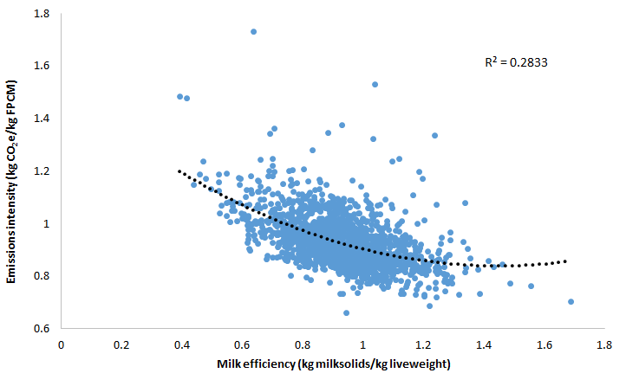

**Figure 29.** Relationship between milk efficiency (kg milksolids/kg liveweight of the milking cow) and milk emissions intensity (kg CO2e/kg FPCM).

One way to improve milk production per kg of liveweight is by increasing the energy density of the diet through grain/concentrate feeding. Figure 30 illustrates the relationship between milk efficiency and EI for three grain feeding groups; low (< 1 t DM/cow.annum), medium (1-2 t DM/cow.annum), and high (> 2 t DM/cow.annum). It must be noted that when undertaking this assessment, it was assumed that all grain/concentrates were fed to the milking cow. This may not always be the case if young stock is also fed grain (e.g. pre-weaned calves to develop their rumen). However, the milking herd will still consume the majority of purchased grain/concentrates. The average EI was 0.98 kg CO2e/kg FPCM for the low grain feeding group, while there was little difference between the medium and high grain feeding groups, both with a mean of EI of 0.93 kg CO2e/kg FPCM. However, as grain feeding increased, the variation between the highest and lowest dataset EI within each grain feeding group declined (data not shown). Thus, it may be concluded that increased grain feeding reduces the variability of EI within each grain feeding group.

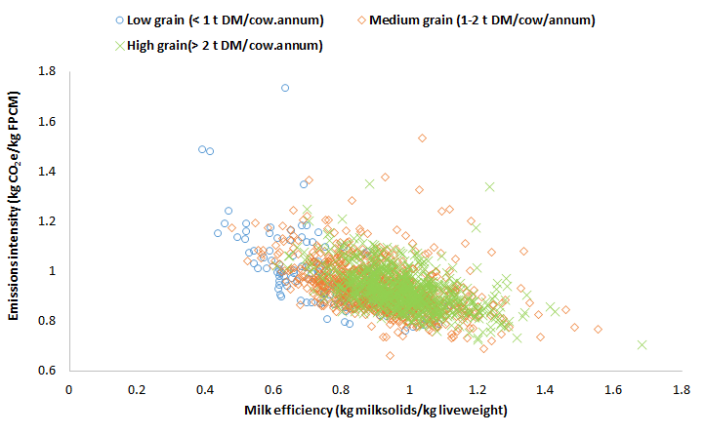

**Figure 30.** The relationship between milk efficiency (kg milksolids/kg liveweight) and emissions intensity (kg CO2e/kg FPCM) for low grain feeding (< 1 t DM/cow; blue circles), medium grain feeding (1-2 t DM/cow; orange diamonds), and high grain feeding (> 2 t DM/cow; green crosses).

Another key input to dairy farms that contributes to net GHG emissions is N fertiliser. Figure 31 illustrates the relationship between N fertiliser inputs (kg N/ usable ha) and EI (kg CO2e/kg FPCM). Note that usable hectares also include runoff/outblocks, and thus the rate of N applied may be lower than applied to the milking platform.

There was a trend towards a slight increase in mean EIs as the rate of N fertiliser/ha increased. The lowest N fertiliser group (< 100 kg N/ha) mean EI was 0.92 kg CO2e/kg FPCM. Mean EI increased to 0.94 kg CO2e/kg FPCM for the next highest N fertiliser group, while there was no difference in EI with the two groups applying 200+ kg N/ha, at 0.97 kg CO2e/kg FPCM (Figure 31). However, farms with reasonably high N fertiliser inputs (> 200 kg N/usable ha) can also exhibit a lower-than-average EI. It must be concluded that these farms are excellent at converting N fertiliser into high-quality forage, which is efficiently grazed/conserved, and then converted into milk production, to dilute the GHG emissions associated with N fertiliser inputs. Conversely, low N fertiliser inputs do not necessarily result in a low EI, given approx. one third of the lowest N fertiliser rate group exhibited an EI greater than the long-term average of 0.93 kg CO2e/kg FPCM.

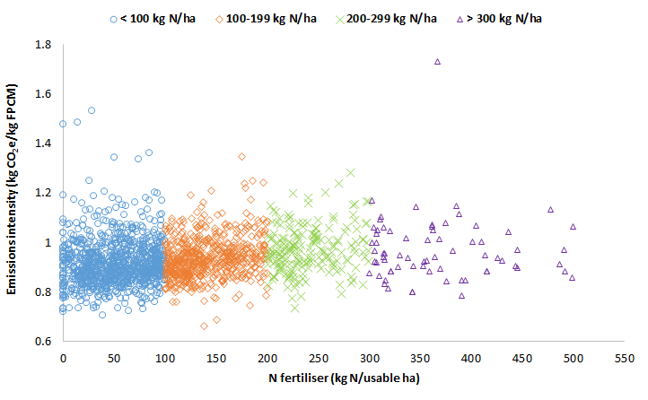

**Figure 31.** The relationship between N fertiliser inputs (kg N/usable hectare) and emissions intensity (kg CO2e/kg FPCM) for four N fertiliser ranges. Low (< 100 kg N/ha; blue circles), medium (100-199 kg N/ha; orange diamonds), high (200-299 kg N/ha; green crosses), and very high (> 300 kg N/ha; purple triangles).

# Resources

*General resources not listed below in abatement/mitigation option reviews*

Agriculture Victoria (2022) Soil Carbon Snapshot <https://agriculture.vic.gov.au/__data/assets/pdf_file/0006/857607/Soil-Carbon-Snapshot-updated-May-2022.pdf>

Dairy Australia’s Land, Water, and Climate website <https://www.dairyaustralia.com.au/land-water-and-climate>

Dairy Australia reducing emissions website <https://www.dairy.com.au/sustainability/reducing-environmental-impact/reducing-emissions>

Dairy Australia Fert$mart manual <https://www.dairy.com.au/sustainability/reducing-environmental-impact/reducing-emissions>

Fert$mart Nitrogen Guidelines: Best management practice <https://www.dairyaustralia.com.au/resource-repository/2021/06/24/fert$mart-nitrogen-guidelines---best-management-practice#.YfH1tepBwnI>

Fert$mart Nitrogen Pocket Guide <https://www.dairyaustralia.com.au/resource-repository/2021/06/24/fert$mart-nitrogen-pocket-guide#.YfH1ROpBwnI>

Moss, A. (2020) Database of nutrient content of Australian feed ingredients. <https://agrifutures.com.au/wp-content/uploads/2020/09/20-078.pdf>

*Abatement option reviews*

There are many reviews of abatement options for ruminant livestock, therefore the listing below is not exhaustive.

Beauchemin KA, Ungerfeld EM, Eckard RJ, Wang M (2020) Review: Fifty years of research on rumen methanogenesis: lessons learned and future challenges for mitigation. *Animal* **14:S1**, s2-s16. <https://www.cambridge.org/core/journals/animal/article/review-fifty-years-of-research-on-rumen-methanogenesis-lessons-learned-and-future-challenges-for-mitigation/8F7537B81CBDA633F48663C1ACF33036>

Black JL, Davison TM, Box I (2021) Methane emissions from ruminants in Australia: Mitigation potential and applicability of mitigation strategies. *Animals* **11**, 951. <https://www.mdpi.com/2076-2615/11/4/951>

Eckard RJ, Clarke H (2018) Potential solutions to the major greenhouse-gas issues facing Australasian dairy farming. *Animal Production Science* **60**, 10-15. <https://www.publish.csiro.au/AN/AN18574>

Eckard RJ, Grainger C, de Klein CAM (2010) Options for the abatement of methane and nitrous oxide from ruminant production – a review. *Livestock Science* **130**, 47-56. <https://www.sciencedirect.com/science/article/pii/S1871141310000739>

Gerber PJ, Steinfeld H, Henderson B, Mottet A, Opio C, Dijkman J, Falcucci A, Tempio G (2013) Tackling climate change through livestock- A global assessment of emissions and mitigation opportunities. (Food and Agriculture Organization of the United Nations (FAO): Rome, Italy). <https://www.fao.org/3/a0701e/a0701e.pdf>

Harrison MT, Cullen BR, Mayberry DE, Cowie AL, Bilotto F, Badgery WB, Liu K, Davison T, Christie KM, Muleke A, Eckard RJ (2021) Carbon myopia: The urgent need for integrated social, economic and environmental action in the livestock sector. *Global Change Biology* **27**, 5726-5761. <https://onlinelibrary.wiley.com/doi/full/10.1111/gcb.15816>

Hristov AN, Oh J, Lee C, Meinen R, Montes F, Ott T, Firkins J, Rotz A, Dell C, Adesogan A, Yang W, Tricarico J, Kebreab E, Waghorn G, Dijkstra J, Oosting S (2013) Mitigation of greenhouse gas emissions in livestock production- A review of technical options for non-CO2 emissions. <https://www.fao.org/publications/card/en/c/87178c51-d4d1-515d-9d0e-b5a6937fa631/>

Hristov AN, Oh J, Firkins JL, Dijkstra J, Kebreab E, Waghorn G, Makkar HPS, Adesogan AT, Yang W, Lee C, Gerber PJ, Henderson B, Tricarico JM (2013) SPECIAL TOPICS- Mitigation of methane and nitrous oxide emissions from animal operations: I. A review of enteric methane operations. *Journal of Animal Science* **91**, 5045-5069. <https://academic.oup.com/jas/article/91/11/5045/4731308>

Hristov AN, Ott T, Tricarico JM, Rotz A, Waghorn G, Adesogan A, Dijkstra J, Montes F, Oh J, Kebreab E, Oosting SJ, Gerber PJ, Henderson B, Makkar HPS, Firkins JL (2013) SPECIAL TOPICS- Mitigation of methane and nitrous oxide emissions from animal operations: III. A review of animal management mitigation options. *Journal of Animal Science* **91**, 5095-5113. <https://academic.oup.com/jas/article/91/11/5095/4731330>

Llonch P, Haskell MJ, Dewhurst RJ, Turner SP (2017) Review: current available strategies to mitigate greenhouse gas emission in livestock systems: an animal welfare perspective. *Animal* **11**, 272-284. <https://www.cambridge.org/core/services/aop-cambridge-core/content/view/2C1E6F2AA8B6608B9B5C49544EEB26F4/S1751731116001440a.pdf/current-available-strategies-to-mitigate-greenhouse-gas-emissions-in-livestock-systems-an-animal-welfare-perspective.pdf>

Min BR, Solaiman S, Waldrip HM, Parker D, Todd RW, Brauer D (2020) Dietary mitigation of enteric methane emissions from ruminants: A review of plant tannin mitigation options. *Animal Nutrition* **6**, 231-246. <https://reader.elsevier.com/reader/sd/pii/S2405654520300706?token=4113F5241001D734B17EB067E8A665DA98A9B4DB00CF0D2264E4708B879AEFB550EC7EDC61A4FB66DF7A5B40D61D2A2E&originRegion=us-east-1&originCreation=20220318052754>

Montes F, Meinen R, Dell C, Rotz A, Hristov AN, Oh J, Waghorn G, Gerber PJ, Henderson B, Makkar HPS, Dijkstra J (2013) SPECIAL TOPICS – Mitigation of methane and nitrous oxide emissions from animal operations: II. A review of manure management mitigation options. *Journal of Animal Science* **91**, 5070-5094. <https://academic.oup.com/jas/article/91/11/5070/4731316>

# Appendices

***Appendix 2***

Typical regional, state, country-wide, and level of grain feeding percentage of GHG emissions, based on several years of DairyBase data (Dairy Farm Monitor Project and Queensland Dairy Accounting Scheme from 2015-16 to 2021-22). Note that with the upgrade of ADCC/DairyBase with respect to tree carbon sequestration, we were unable to generate a percentage of net emissions attributed to carbon sequestered in trees.

|  |  |  |  |  |  |  |  |  |
| --- | --- | --- | --- | --- | --- | --- | --- | --- |
| **Source/sink GHG emissions** | **Australia-wide** | **Victoria** | **VIC- Gippsland** | **VIC- Northern** | **VIC-**  **South West** | **New South Wales** | **NSW-**  **North** | **NSW-**  **South** |
| Enteric CH4 | 60% | 60% | 60% | 61% | 58% | 58% | 56% | 59% |
| Waste CH4 | 9% | 10% | 10% | 10% | 9% | 10% | 9% | 11% |
| N2O direct grazing | 3% | 3% | 3% | 3% | 3% | 3% | 3% | 3% |
| N2O Manure storage & spread | 1% | 1% | 1% | 1% | 1% | 1% | 1% | 1% |
| N2O Indirect N waste | 2% | 2% | 2% | 1% | 2% | 2% | 2% | 2% |
| N2O Direct N fertiliser | 3% | 3% | 3% | 3% | 3% | 3% | 3% | 3% |
| N2O Indirect N fertiliser | 2% | 2% | 2% | 1% | 2% | 2% | 2% | 1% |
| Electricity | 4% | 5% | 4% | 5% | 5% | 6% | 7% | 5% |
| Fuel | 2% | 2% | 1% | 2% | 2% | 2% | 2% | 2% |
| Urea & Lime | 2% | 2% | 2% | 1% | 2% | 2% | 2% | 1% |
| Concentrates | 5% | 5% | 5% | 5% | 5% | 5% | 5% | 6% |
| Fodder | 1% | 1% | 1% | 3% | 1% | 1% | 1% | 2% |
| Fertiliser | 5% | 5% | 6% | 3% | 6% | 5% | 6% | 4% |
| Trees | 0% | 0% | 0% | 0% | 0% | 0% | 0% | 0% |

***Appendix 2 cont.***

Typical regional, state, country-wide, and level of grain feeding percentage of GHG emissions, based on several years of DairyBase data (Dairy Farm Monitor Project and Queensland Dairy Accounting Scheme from 2015-16 to 2021-22). Note that with the upgrade of ADCC/DairyBase with respect to tree carbon sequestration, we were unable to generate a percentage of net emissions attributed to carbon sequestered in trees.

|  |  |  |  |  |  |  |  |  |  |
| --- | --- | --- | --- | --- | --- | --- | --- | --- | --- |
| **Source/sink GHG emissions** | **Queensland** | **QLD-**  **North** | **QLD-**  **South** | **South Australia** | **Tasmania** | **Western Australia** | **Low grain1** | **Med grain1** | **High grain1** |
| Enteric CH4 | 60% | 61% | 60% | 61% | 66% | 60% | 64% | 60% | 59% |
| Waste CH4 | 9% | 9% | 9% | 10% | 8% | 8% | 9% | 9% | 9% |
| N2O direct grazing | 3% | 3% | 3% | 3% | 4% | 3% | 4% | 3% | 3% |
| N2O Manure storage & spread | 1% | 1% | 1% | 1% | 1% | 1% | 1% | 1% | 1% |
| N2O Indirect N waste | 2% | 2% | 2% | 2% | 2% | 2% | 2% | 2% | 2% |
| N2O Direct N fertiliser | 3% | 4% | 3% | 3% | 4% | 3% | 4% | 3% | 3% |
| N2O Indirect N fertiliser | 1% | 1% | 1% | 1% | 2% | 2% | 1% | 2% | 1% |
| Electricity | 4% | 4% | 4% | 3% | 1% | 3% | 3% | 5% | 4% |
| Fuel | 2% | 2% | 2% | 3% | 1% | 2% | 2% | 2% | 2% |
| Urea & Lime | 2% | 2% | 1% | 1% | 2% | 2% | 2% | 2% | 1% |
| Concentrates | 6% | 5% | 6% | 5% | 4% | 6% | 3% | 4% | 6% |
| Fodder | 1% | 1% | 1% | 2% | 1% | 1% | 1% | 1% | 1% |
| Fertiliser | 5% | 5% | 4% | 5% | 6% | 6% | 5% | 6% | 5% |
| Trees | 0% | 0% | 0% | 0% | 0% | 0% | 0% | 0% | 0% |

1 Low grain feeding = < 1 tonne DM/cow.lactation, medium grain feeding = 1-2 tonnes DM/cow.lactation, high grain feeding = > 2 tonnes DM/cow.lactation.