Principles for developing an effective grazing management system for ryegrass-based pastures

Danny Donaghy¹ and Bill Fulkerson²

1. Tasmanian Institute of Agricultural Research, Burnie Tasmania
2. New South Wales Agriculture, Wollongbar NSW



The importance of pastures, and the challenge for farmers

In a business, profit is the key determinant of success, and in a pasture-based system of animal production such as we have in Australia, profitability is closely linked to utilisation of pasture, the cheapest source of feed.

Across Australia and New Zealand, we can produce pasture for between 3 to 10c/kg dry matter (DM) (concentrates can vary from 12 to 40c/kg DM or more). However, if pasture is not managed properly, an increasing amount is wasted, and the productive life of the pasture is reduced. In this situation, pasture then becomes a more expensive source of feed.

So what are the potentials for southern Australia?
- Maximum production from perennial ryegrass/white clover - 18 to 20t/ha/year under ideal conditions of environment and management.
- Maximum utilisation - 80 to 90% of the potential production.
- Maximum persistence - 5 to 10 years or more at this level of production.

However, most dryland dairy pastures are producing between 5 and 12t DM/ha/year (under irrigation about 25% more), average utilisation is estimated to be around 50 to 60% of potential able to be utilised, and lack of persistence of perennial pastures is increasingly becoming an issue for farmers.

The challenge facing farmers is to manage pastures and supplements, in order to move closer to these potentials. The aim of good pasture management is to grow a large amount of high quality pasture, the majority of which will be either eaten or conserved, and which will persist for the maximum possible time. We are fortunate that these four factors - productivity, quality, utilisation and persistence - are linked, and recent research has proven that similar management can maximise all four factors.

This management is based on a clear understanding of how pasture plants grow, and what they require in order to perform at their best, and builds on research undertaken in several Australian States, begun by Bill Fulkerson and Peter Michell.

Agronomy of pasture grasses in relation to growth and survival

In its simplest form, grass is a population of tillers. Tillers are the functional units of ‘bunch’ grasses such as ryegrass, fescue, cocksfoot, phalaris and paspalum. Each tiller has its own leaves and roots, but is connected to other tillers at the base of the plant, and so can share water, nutrients and carbohydrates. Tillers, and therefore the root system of the plant, have a lifespan of about a year, and originate, along with leaves, from growing points located at the base of the plant (see figure).

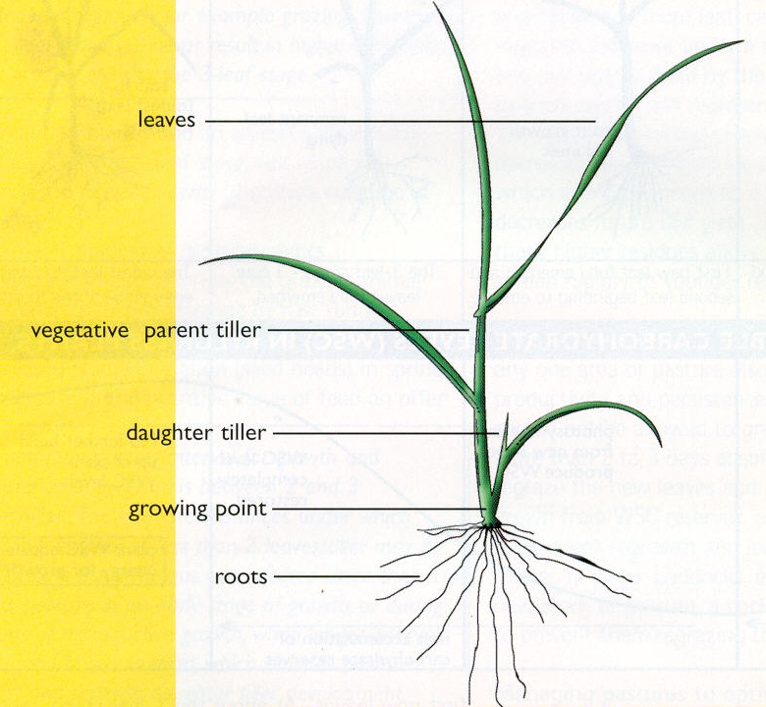

Tillering is influenced mainly by light, nutrient supply (especially nitrogen) and temperature. Tillering is highest under high light levels, mild temperatures (13 to 25ºC) and adequate moisture and soil nutrient availability.

Once emerged, the daughter tiller is completely reliant on the parent until it develops its own leaves and roots, and this generally takes several weeks. If the parent tiller is stressed during this time, the daughter tiller will be sacrificed and will die.

There are 2 major periods of tillering in southern Australia - spring and autumn. If moisture is not limiting over summer, as under good irrigation, plants can continue to tiller over this period too, although research suggests spring is still the major period of tiller formation. Because tillers only have a limited lifespan, management that maximises tiller survival and replacement will ensure maximum pasture production and persistence.

The lifespan of a leaf is equal to the time taken for 3 leaves to grow per tiller. Thus, each tiller maintains a maximum of about 3 live leaves - as each new leaf emerges after this ‘3-leaf stage,’ the oldest leaf dies. This is a basic principle on which sound pasture management practices are based, that leaves have a limited lifespan, and if they are not harvested (grazed), they will die and be wasted.

From the process of photosynthesis in sunlight, tillers form glucose and then other water soluble carbohydrates (WSC) in the leaves. These WSC are used to provide energy for ongoing growth and respiration. What is not immediately used for growth or respiration is stored, mainly in the lower portion of the tillers, and remobilised when needed.

There is substantial evidence that the availability of WSC in ryegrass tillers has a marked effect on the plant’s regrowth potential and ability to persist. Recently it has also been shown to be important from an animal nutrition viewpoint as well, as WSC is the most readily available form of carbohydrate from pasture in the rumen.

Regrowth of a ryegrass tiller

WSC are particularly important in sustaining plant growth when photosynthesis is unable to provide enough energy to meet the plants demands, for example immediately following grazing, during cloudy weather, or at night. Regrowth of a ryegrass tiller, and the accompanying change in WSC, is shown in the following figure.

1. 2. 3. 4.
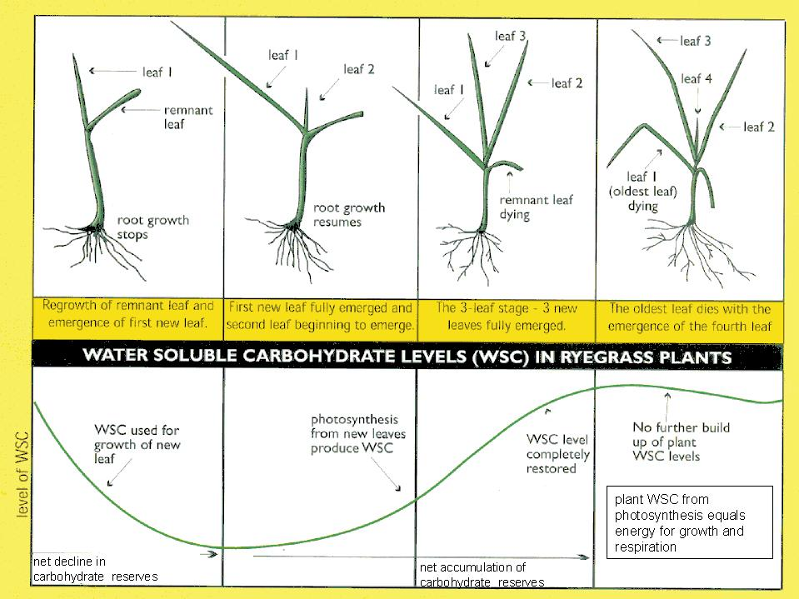
Regrowth proceeds in this manner because there is a priority for available WSC stores.

1. Following grazing, the tiller’s first priority is always to re-establish its energy ‘factory’, by regrowing leaves - if it does not do this, then ongoing respiration will 'burn up' available WSC, and the tiller will die. Other processes such as root growth and the growth of daughter tillers stop or are retarded, and WSC is mobilised from the remaining tiller stubble to provide energy for regrowth of the first new leaves.

2. As the new leaf starts to expand and grow, it makes its own WSC from photosynthesis, however all of this new WSC is used for growth of the leaf, and none is stored. The tiller is still using WSC reserves too, and it is not until about the 1-leaf stage (1 new leaf fully emerged) that WSC begins to be stored. This is the 'trigger' for roots to begin growing again. At this stage the plant is most vulnerable to regrazing, as WSC levels are low, roots are only starting to regrow, and daughter tillers are receiving little if any support from parent tillers.

3. At around the 2-leaf stage of regrowth, WSC reserves have been built up sufficiently for the plant to again cope with being grazed. Supply of WSC to daughter tillers begins again, and new tillers start to emerge. This may be considered as the minimum grazing interval. As the tiller expands another leaf (3-leaf stage), root growth and tillering are now fully active, WSC levels in the tiller bases have been further replenished, and overall growth is at a maximum.

4. As the 4th leaf emerges, the oldest leaf (leaf 1) begins to die, so that the tiller maintains 3 live leaves. At this stage, pasture quality begins to decline and increasing amounts of pasture are wasted. The 3 to 3½-leaf stage is considered to be the maximum grazing interval.

In addition to the importance of WSC in regrowth, they also play a role in survival of plants through periods of stress such as heat, frost and drought. Given all these factors, it is clear that management that maximises WSC buildup and storage will have beneficial effects on plant growth and survival (persistence).

The effect of regrowth on pasture quality

Carbohydrate and protein: For the rumen to function properly animals require a balance between soluble protein and soluble carbohydrate (i.e. WSC) in pasture eaten - at least as much carbohydrate as there is protein, if not more. If there is too much soluble protein, it is converted to ammonia in the rumen. This excess ammonia needs to be detoxified to urea and excreted in urine. This process requires energy, and therefore may have a negative effect on both production and reproduction in the grazing animal.

In general, green growing pasture contains more than enough protein for the dairy cows' requirements, but carbohydrate (energy) may be the limiting factor. Recent research has shown that the ratio of soluble protein to carbohydrate becomes more balanced after the 2-leaf stage, as WSC levels increase with regrowth, while protein levels decline due to leaf maturity. The ratio of crude protein to WSC can be as high as 5:1 at the 1-leaf stage, changing to 1:2 at the 3-leaf stage.

Digestibility: There is no change in either digestibility or metabolisable energy (ME - the total energy available to the animal for growth and production) of feed on offer with regrowth up to the 3-leaf stage. However after the 3-leaf stage, both digestibility and ME decline and fibre increases with a build up of dead leaf and stem material.

Minerals: The levels of minerals in ryegrass change markedly with regrowth - potassium, which is usually at levels far in excess of the animal’s requirements, declines, while calcium and magnesium, important for milk production, increase with regrowth to the 4-leaf stage. One indicator of appropriate mineral status for performance of dairy cows is the ratio of potassium over calcium and magnesium - there is reasonable evidence that this ratio should be below about 2.2 to reduce the incidence of grass tetany and other metabolic problems. The ratio falls from about 6 at the 1-leaf stage, to below 2.2 at the 3-leaf stage.

Another indicator of appropriate mineral status is the ratio of calcium to phosphorus - the recommended ratio for milking cows is above about 1.6:1. In ryegrass this ratio changes from about 1:1 at the 1-leaf stage, to over 2:1 at the 3-leaf stage.

Grazing management to optimise ryegrass performance

There are 3 aspects to grazing management - these are interval (when to graze), intensity (how hard to graze) and duration (how long to graze).

Grazing interval.
Determining when to graze a pasture based only on pasture height (standing DM) takes no account of several factors that strongly influence the height of pasture:
- differences in plant genotype - short-rotation ryegrasses (annual and biennial) are generally larger than perennial genotypes at any given stage of regrowth, although leaf stage is still comparable.
- differences in plant cultivar - even within the perennial ryegrass genotype, growth rates and plant structure can vary between cultivars, although again, leaf stage is still comparable.
- differences in pasture composition - other species in pasture (legumes, other grasses) can vary in growth habit and DM content.
- differences in soil fertility (particularly availability of nitrogen), water and temperature.

On the other hand, a grazing interval based on leaf stage is not only sensible (leaf stage is a plant indicator of time to graze; pasture height and DM on offer, and cow days are animal indicators) but practical and simple.

A grazing interval coinciding with regrowth of 2 to 3 leaves/tiller is optimal for ryegrass persistence, productivity, utilisation and quality. This is based on allowing plants time to recover from the previous grazing and build up their WSC levels.

The time between appearance of one leaf and the next (leaf appearance interval) is determined mainly by temperature; the 1-leaf stage may be 5 to 7 days in spring, when growth is fast, and 20 to 30 days in mid-winter, but will vary from year to year with variation in temperature. Thus, regrowth stage should be monitored regularly each year - a grazing management strategy that is successful one season, or one year, may not work as well the next.

Consequences of a shorter grazing interval:
From both a plant’s and an animal’s perspective, grazing at less than the 2-leaf stage depletes WSC reserves and leads to:
- decreased DM yield - shorter grazing rotations than this will never result in greater growth; all plants require a rest period to grow at their maximum
- decreased plant survival, particularly during stress periods (drought, heat, frost)
- increased invasion of less desirable plant species into the pasture
- retardation and death of the root system, and an increase in sod pulling (plants pulled out of the ground under grazing)
- decreased tillering
- an increase in tiller death, especially daughter tillers
- an imbalance to the grazing animal in soluble protein to energy levels - pasture is too high in soluble protein and too low in soluble carbohydrates
- an imbalance to the grazing animal in mineral levels - calcium and magnesium may be too low and potassium too high

Advantages of a shorter grazing interval:
The only times an interval of less than 2 leaves/tiller may be beneficial are:
- if rust fungus has infected more than 1/3 of the pasture at an early stage of regrowth (usually in late spring),
- during reproductive growth, when shorter intervals encourage vegetative tillers and prevent seed set,
- summer grazing - in summer-dry areas, ryegrass often becomes semi-dormant due to a combination of high temperatures and dry conditions, and leaf appearance interval is increased (1-leaf stage may be 10 to 20 days). In areas where summer-active grasses such as paspalum and kikuyu are prevalent, pasture may benefit from being grazed at the 2-leaf stage or earlier, to prevent these summer grasses from becoming dominant. The shorter grazing intervals will do less harm to the ryegrass during this period than letting summer grasses dominate the pasture, as ryegrass plants have 'shut down', and are not as active.

Consequences of a longer grazing interval:
From both a plant’s and an animal’s perspective, grazing after the 3-leaf stage, even though an increase in growth rate may still be measured, will result in:
- an increase in dead leaves, representing wastage of feed
- increased shading of ryegrass tillers and clover stolons
- a greater chance of damage by rust fungus (if present)
- increased stem elongation (seed heads) in spring
- a decrease in the nutritive value of feed, because fibre increases, while digestibility and ME levels decrease
- a decrease in utilisation by the grazing animal

Grazing intensity.
The ideal grazing residue for ryegrass should leave 4 to 6cm of stubble; depending on pasture density and composition, this residual will vary across Australia from 900 (open pasture) to about 1600 (dense pasture) kg DM/ha.

Consequences of grazing too hard:
Grazing lower than about 4cm into the pasture may initially stimulate tillering of ryegrass and increase white clover content through increased light penetration, and may represent an immediate increase in utilisation. However, these initially positive effects are more than countered by:
- decreased animal productivity
- decreased WSC plant reserves, as a greater part of the WSC storage organ (tiller) is removed
- decreased DM yield
- decreased ryegrass plant survival and increased invasion of less desirable plant species
- growth retardation and death of the root system
- increased tiller death
- an increase in soil surface temperature (which can exceed 40ºC in summer, and kill plants)

Consequences of grazing too laxly:
A grazing residual of greater than about 6cm, by leaving behind more leaf will usually result in faster regrowth, however under a normal grazing rotation, this leaf will be dead by the time the animals are back to regraze the pasture, so represents a waste of feed. In fact, leaf death occurs sooner when greater residuals are left after grazing. Also, the leaves left behind are generally older and less photosynthetically efficient than younger leaves, and in addition, will be selected against by grazing animals, as they are of lower nutritive value.

The increased shading provided by this lax grazing decreases ryegrass tillering and white clover growth, which eventually leads to a more open pasture and decreases potential DM yield. If rust is present, higher post-grazing residues allow it to build up and spread more rapidly to younger regrowing leaves.

Remember, whatever the short-term gains in regrowth of leaving higher residuals may be, leaves still have to grow all the way up from ground level - the longer the residue, the further the journey and the greater the waste of pasture which could otherwise have been utilised. There is also evidence that by the time these leaves emerge into the sunlight, they have lost some of their ability to photosynthesise, so it really is a case of false economy to leave too much pasture behind. The only benefit of slightly longer residuals (up to 6cm) is during summer, when low residuals (e.g. 3 to 4cm) would increase soil temperature and speed up the drying out of soil.

Post-grazing residues are a good practical indicator of how well cows are being fed - much higher than about 5 or 6cm (and uneven) indicates cows are too well fed and are starting to waste pasture, while much below about 4cm indicates cows are still hungry.

Grazing duration.
In general, animals should not be allowed to graze any one area for more than 2 to 3 days absolute maximum. Animals regraze the new leaves and shoots, which have grown from WSC reserves, and this severely reduces subsequent regrowth and jeopardises survival of tillers. If cows are grazed in larger paddocks for more than 2 days, a back fence should be used to prevent them regrazing the previous area.

The role of supplements in managing pastures

Following are some general comments regarding the use of supplements (silage, hay, grain, other feed mixes) to achieve pasture management goals.

Although the optimum grazing interval, intensity and duration are now known, in practice there are times when feed shortages will still occur - mainly due to adverse climatic conditions that reduce pasture growth - and pastures tend to be overgrazed (too quickly and/or too hard) during these times, unless some form of supplementary feed is available. These supplements can play a valuable role in pasture management, if used sensibly.

The major role of supplements should be to provide farmers with the security to increase stocking rates and hence increase the potential to improve pasture utilisation during periods of surplus (e.g. the spring 'flush' of growth). In this manner, supplements are used to overcome seasonal shortages in pasture growth (feed gaps) and quality, and provide the flexibility to manage pasture properly. For example, feeding supplements when post-grazing residues are too low (lower than 4cm) will allow more optimal residues for the pasture to build up, and also result in optimal intake for the stock grazing them. Similarly, feeding supplements to slow down the grazing rotation toward winter (when pasture growth rate is naturally low) or during a dry summer, will allow cows to maintain an optimal grazing interval (between the 2 and 3-leaf stage).

Feeding supplements to animals simply to increase production per cow irrespective of pasture availability will lead to low response rates. For example, the maximum milk response to 1kg of good quality barley grain in theory is 2.5 litres, however in practice, research has shown that the actual response will vary from zero to 1.5 litres of milk. In fact, recent research has found that the highest response to supplements is about 1.7 litres of extra milk per day for each kg of concentrate fed, even when longer-term effects such as an increase in body size and improved condition were taken into account.

The response to supplements will depend on the rate of substitution of grass for supplements, and the effect of the supplements on digestion of pasture in the rumen. The highest responses will be from the first few kg of supplement fed per day, to high genetic merit animals in peak lactation fed poor quality pasture. Supplementing cows on abundant, good quality pasture will result in a decrease in pasture utilisation. The economics of feeding high levels of supplements must be considered carefully - extra milk produced must cover the increased feed costs, or the farm business will go backwards.

Remember that it is profitability not productivity that is important in business success.

For further information on the results presented in this document, contact:

Danny Donaghy
Tasmanian Institute of Agricultural Research, PO Box 3523, Burnie TASMANIA 7320
Tel: 6430 4937 or mobile 0408 994 177 Fax: (03) 6430 4959
E-mail: danny.donaghy@utas.edu.au

